Planar® LookThru™ OLED Transparent Display
Content Developer’s Guide

Table of Contents

How Transparent OLED Works 3
History and Definitions 3
Pixel Structure 3
Developing Content for a Planar LookThru OLED Display 4
How Transparent OLED Displays are different from Traditional LCD Displays 4
How Transparent OLED Displays are different from Transparent LCD Displays 4
Seeing Black 5
Seeing White 6
Seeing Highly Saturated Colors 7
Mocking Up Content for Installation Renderings 8
Installation Considerations 8
Maximizing Transparency with Content 8
Adjusting Transparency with Lighting 8
Readability Through the Display 9
Seeing Through the Back of the Display 9
Tiling Planar LookThru OLED to Create a Transparent Video Wall 11
Lifetime Considerations 12
Static and Moving Video Images 12
Accumulated Stress 13
Other Lifetime Considerations 13

How Transparent OLED Works

History and Definitions
OLED is a flat panel display technology which has been in development for decades and shows incredible promise as a display technology. OLED (Organic Light Emitting Diode) technology was first formulated at Eastman Kodak in the early 1980s. The first commercial, limited production OLED displays were sold in 1997. Since then these displays have found use in car stereos, MP3 players and cameras, but by far the largest market for OLEDs to date has been smart phones where under the radar over half a billion have been sold. In the past few years a limited number of Full HD panels at 55” and larger have become available, where the duty cycle is limited and the risk of burn-in from static content is minimized, like for consumer television applications.
The term “organic” doesn’t imply these displays are pesticide free or made from naturally-grown products; rather it refers to the fact the semiconducting materials used to fabricate the light-emitting diodes are carbon-based.
OLED is a very promising technology. The benefits of the technology are wide color gamut, viewing angle, contrast ratio, power usage (with typical video content), and thinness. As a core technology, OLEDs promise to be thinner than LCDs, have faster refresh rates, and can be produced on flexible plastic substrates for durability, weight, and clever mechanical designs. All of this promise for the future keeps investment going into the core technology.
The downsides to OLED displays are generally cost, commercial availability and lifetime. As a data point, the cost for a LED-backlit LCD TV is one-quarter (or less) the price of an OLED version in the same diagonal. OLED displays are prone to image retention and static content should be avoided. The overall lifetime of the display is diminished as organic materials degrade. For commercial flat panel applications where true 24x7 operation is required for static content display, we recommend the range of Planar’s other large format LCD displays (Planar® PS Series or Planar® EP Series, Planar® UltraRes™ Series, Planar® UltraLux™, etc).

Pixel Structure
Each “pixel” of within a Planar® LookThru™ Transparent OLED Display is made up of four segments. The largest is a clear segment, allowing for transparency. The others are color segments for red, green and blue. You can see this structure fairly clearly using the magnification on your camera phone up close on the display.
There is a direct relationship between transmissivity (the perception of transparency) and resolution. The more pixels that need to be displayed on the screen (in their RGB sub-pixels) the less space there is available for clear sub-pixels that viewers can see through. So, the Full HD resolution of the Planar LookThru OLED display optimizes the image clarity and transparency in the 55” size.
See Planar’s “9 Things to Know about Transparent OLED” eBook for additional information about the display architecture.

Developing Content for a Planar LookThru OLED

How Transparent OLED Displays Are Different From Traditional LCD Displays
Traditional LCD displays are structured in such a way that the backlight (which is always on) is shuttered by electrically-charged liquid crystal material to let the light through or to block it. This combined with a color filter creates the images on the display. Most LCD displays are not transparent.
OLED is an emissive technology, which means that each pixel lights up individually and no backlight is required. Pixels that are black are “off.” In a transparent OLED display, those off pixels are see through to the point of the transmissivity of the display.
This is illustrated well in the image below. When you put a standard gradient test pattern (from white on the left hand side to black on the right hand side) on a transparent display, the left side is opaque and the right side is see through. When you put that same image on a stand backlit LCD (whether the backlight is LED or CCFL) the result is a picture where the white and dark section are equally opaque.
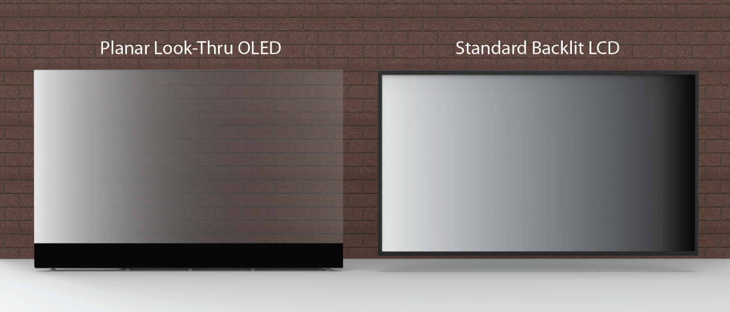
Figure 1 Comparison between a transparent OLED and a traditional LCD display

How Transparent OLED Displays Are Different From Transparent LCD Displays
If you are familiar with the transparent LCD product, like the Planar® LookThru™ Display Box and Planar® LookThru™ Open Frame Installation Kit Display, then you know that it works the opposite of OLED. On a transparent LCD, white is clear and black or dark is opaque. Similar to how an overhead transparency or slides work. This means that on a transparent LCD display you cannot achieve floating white text on a clear background (without the use of other enabling technologies). Similarly, on a transparent OLED you cannot have floating black text on a transparent background.

Seeing Black
Black pixels on a transparent OLED display are clear. In the image below, you can see this effect clearly. The background image of this content is entirely black. The effect with the face of this cat is very compelling as the fur of the face blends into the background smoothly. Beside it is a picture of what the image looks like in Photoshop.
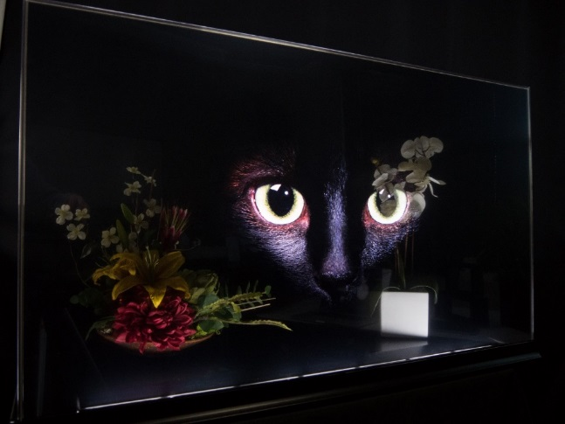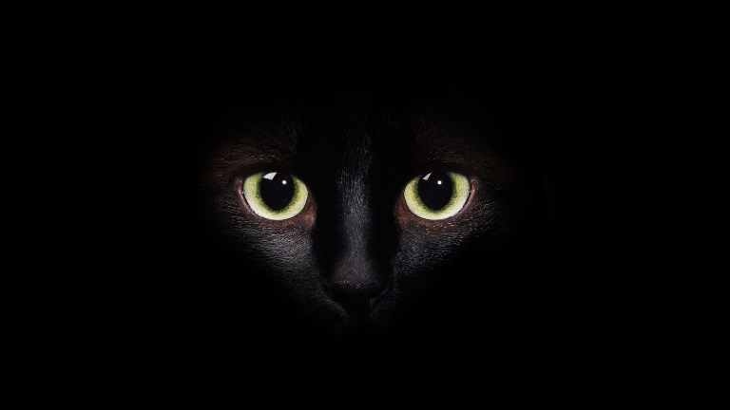
Figure 2 - The same image on the transparent display on the left and the image to the right is the picture as it appears in Adobe® PhotoShop® or a photo editing program. This mostly black image as shown on a Planar LookThru OLED transparent display. Note: there is a small light strip behind this display that was put there to light the floral arrangements behind the screen. That is not part of the product itself.
On a transparent OLED display you cannot depict black text on a transparent background because black is transparent. Dark gray or charcoal is distinguishable from black, as you can see in the image above.
Full screen imagery and video brings the eye forward and can be stunning. You will notice in these examples, however, that the dark or black portions of the image will be transparent. In the image below, of the vibrant night sky reflected on a lake, that the dark lake waters and tree outlines are transparent and make the physical objects behind the display visible.
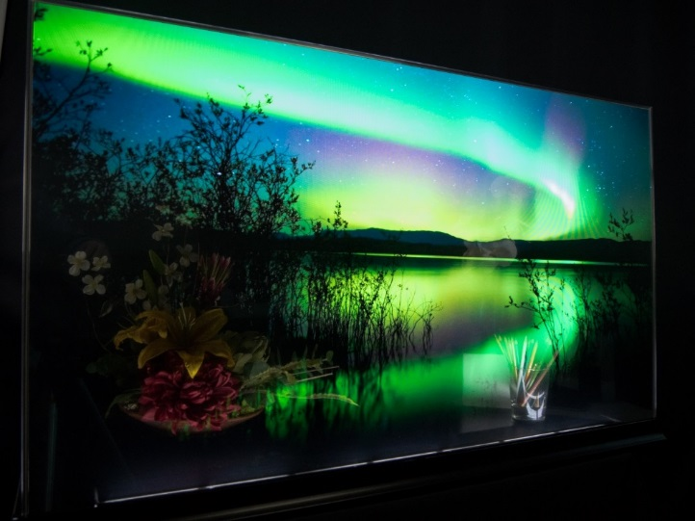
Figure 3 - Full screen image on a Planar LookThru OLED transparent display. To the right is the image as it appears in Photoshop (note the black is opaque in the image). Note: there is a light strip in this image that is not part of the product.

Seeing White
With the Planar LookThru OLED you can achieve floating white text or imagery. As illustrated in the photo below.
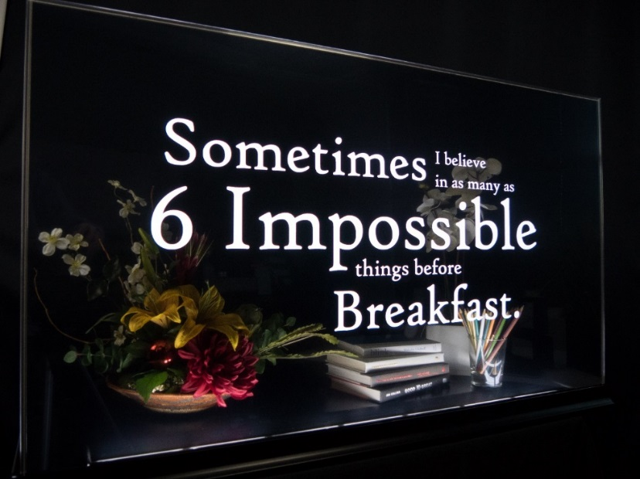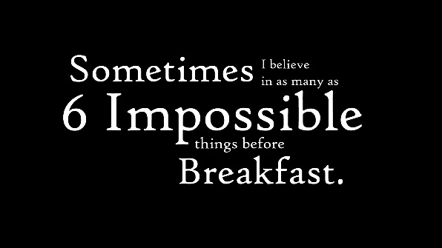
Figure 4 - White text appears to float in the middle of a clear screen. To the right is the image as it appears in PhotoShop with an opaque black background. Note: there is a small light strip behind this display that was put there to light the floral arrangements behind the screen. That is not part of the product itself.

Seeing Highly Saturated Colors
The outstanding color performance of Planar LookThru OLED is demonstrated when you display highly saturated colors.
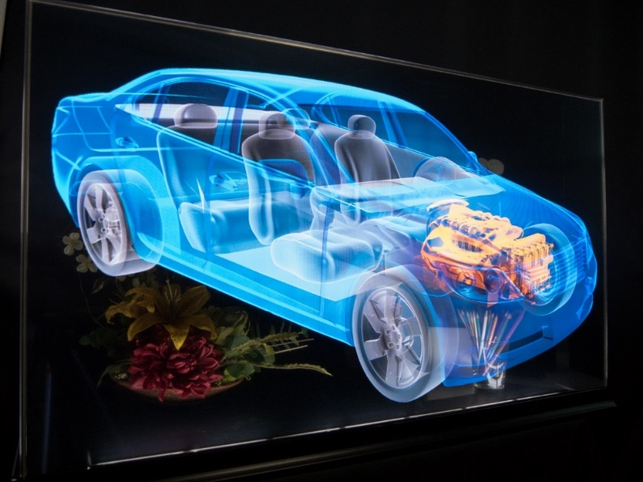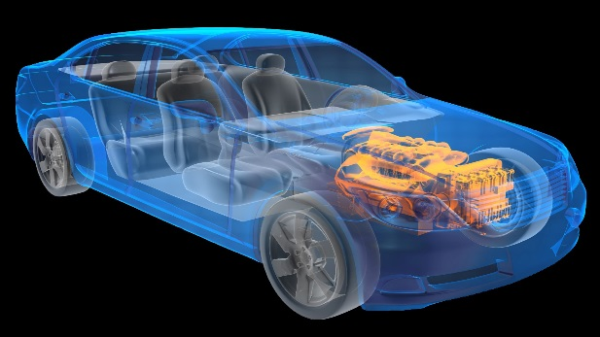
Figure 5 - Rich colors like blue and yellow appear to jump off the screen. To the right is the image as it appears in PhotoShop.
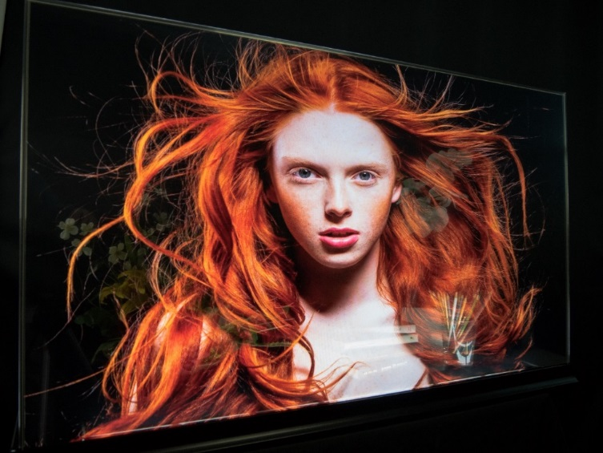
Figure 6 - Colors like highly-saturated red are stunning on the display and because of the wide viewing angle, eye-catching from afar. The image to the right shows the picture as it appears in PhotoShop.

Mocking Up Content for Installation Renderings
Often designers will be asked to mock up environmental shots showing a Planar LookThru OLED in an environment. The CAD drawings available on Planar.com/Lookthru are a great resource in preparing these mock-ups and the next question is always about how to simulate what content will like on these displays.
We talked to a few experienced designers who are familiar with the Planar LookThru OLED and here is the advice that they provided.
- If you are using a static photograph, remove all black or dark areas in Photoshop (or other editing program) and make that area of the image transparent.
- If you are using a vector image, start with a transparent background.
- If you are using video or motion graphics, the best results are achieved when setting the Layer Blending mode in Photoshop to ‘Screen’ for a given piece of content. This is the most accurate representation. From there, make other adjustments/enhancements depending on the actual image itself, such as glazing in any given rendering will pick up highlights or reflections from the environment itself. Due to the punchiness of the white and the wide color gamut of the display, sometimes manual adjustment of the contrast and gamma of the image may be required to make it appear more realistic.

Installation Considerations

Maximizing Transparency with Content
Each individual pixel will only appear transparent if the pixel isn’t lit with bright or light content, so lots of black content on the screen is advised. When Planar develops content for demonstration, we prefer each screen having at least 75% black content visible at all times, to show off the transparency.
If you are showing full-screen video content, the average content there is 65% black or more. Cinema and film tends to have darker average luminance and cartoons and digital signage tends to have higher average luminance.

Adjusting Transparency with Lighting
Just like any clear piece of glass, the ambient light will greatly affect the perceived transparency. The windows facing into a dark room will appear opaque and when the light is bright within the rooms of a house, the windows suddenly appear clear. The same applies to a transparent display. If you place objects or scenes behind the screen and keep them in the shadows, the image on the face of the display will appear more opaque (drawing the eye forward to the content on the screen). The same scene, when well lit, either with uplights or downlights, will suddenly draw the viewer’s eyes to the background, through the display screen.
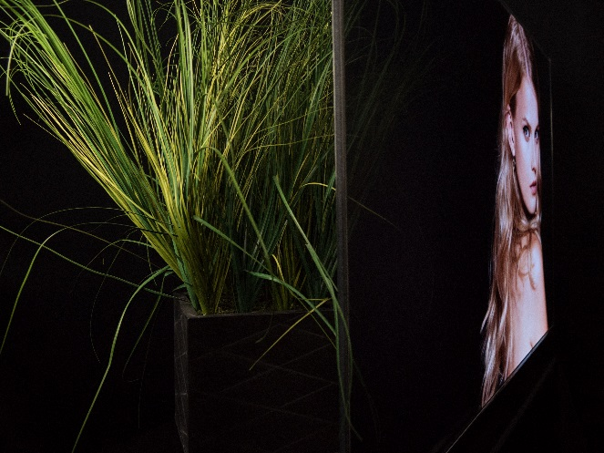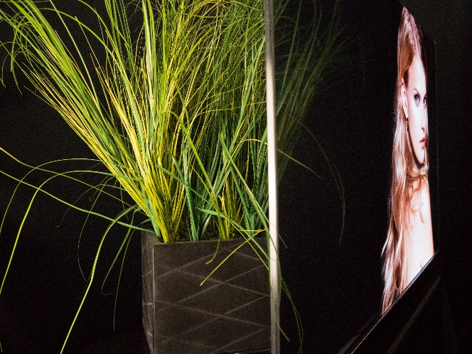
Figure 7 - Minimal lighting behind a display renders the display more opaque. Bright lighting behind the display makes the screen appear more transparent, as evidence by the grass behind visible through the display in the second image when it is not visible in the first image.

This leads to great opportunities for orchestrating ambient lighting with screen content to create different customer experiences, drawing their eyes forward and back to tell a story in 3-dimensional space.

Readability Through the Display
In our testing, you can read text down to 10 or 12 point size on product packaging or merchandise within a few inches of the display and see larger signs or scenes from dozens of feet away. Book titles, logos on products and even details on watch faces in a display case will be quite visible. There is a prominent pixel structure visible when you get up close on the display (appears to be a small screen door effect), so it isn’t as uniform as tinted glass or acrylic and it isn’t as clear as regular tempered glass, but for retail merchandising, museum exhibit display, and the like the transmissivity should be adequate.

Seeing Through the Back of the Display
The Planar LookThru OLED has nearly a 360 degree viewing angle. Because it doesn’t require a light box behind the display, the content on the screen is visible from the back at a reduced brightness and perceived contrast. Our observations reveal about 25% less contrast and brightness on the back then the front of the display which still results in a visible image. And because the display is emissive, the viewing angle is exceptional from all sides.
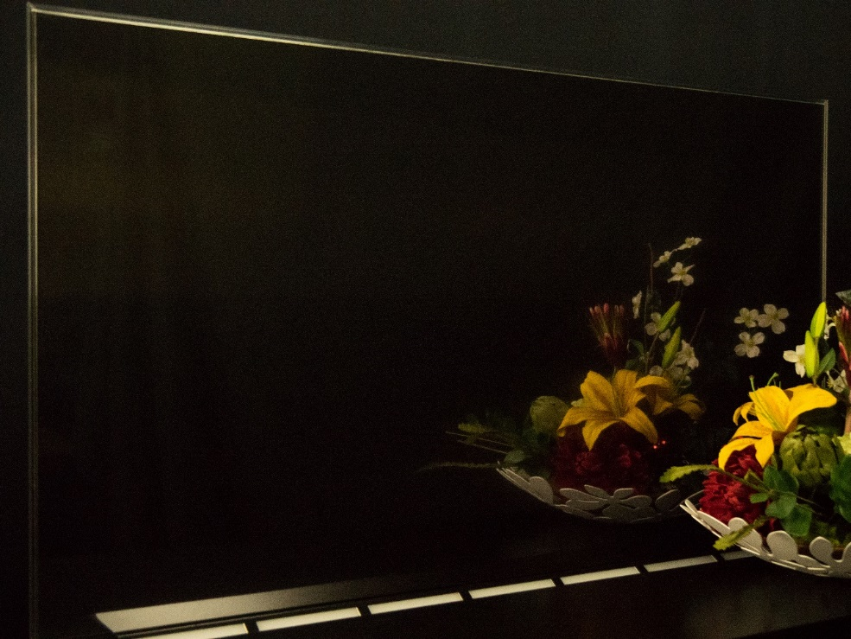
Figure 8 - This image shows the back of a display (with a third-party lighting strip used to light the floral arrangement that is not part of the product). You can see the physical floral arrangement in the foreground and a reflection of that floral arrangement on the back of the screen without any content shown (full black or off).
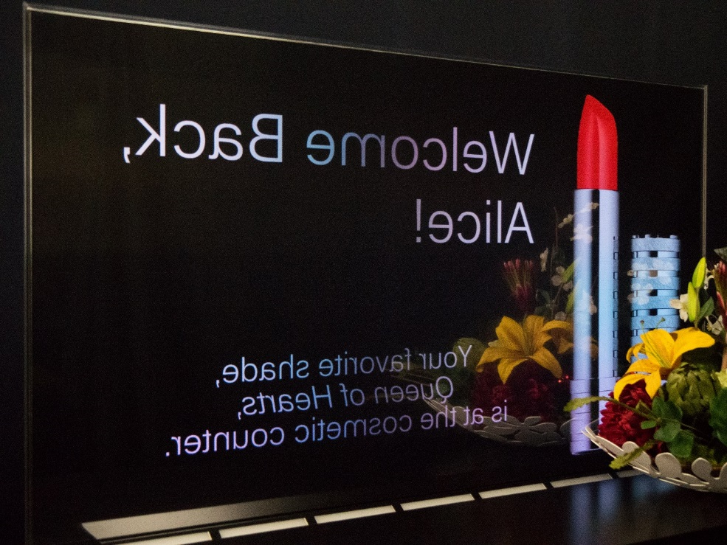
Figure 9 - This image shows the same scene as Figure 8, but with content on the screen. You can still see the reflection of the flowers, but it is diminished because of the visible content.

Tiling Planar LookThru OLED to Create a Transparent Video Wall
Planar has created a 55” display, not a video wall solution. But just like any display in our line-up, customers can create a video wall with clever mounting solutions and the use of a processor, like Planar’s Clarity® Visual Control Station™ (VCS™) Video Wall Processor, with each output of the processor powering an individual display.
The Planar LookThru OLED 55” displays has three small bezels (4mm of inactive area) on the top, right and left hand edges. The bottom edges has a black bar (behind the smooth Corning® Gorilla® Glass surface) of approximately 3”. As a result of this bezel un-uniformity, we recommend video walls that are 2-high in landscape or 2-wide in portrait. They can be any width or height in those configurations. You will see examples of lots of video wall configurations in the application imagery on the product website, like the following.
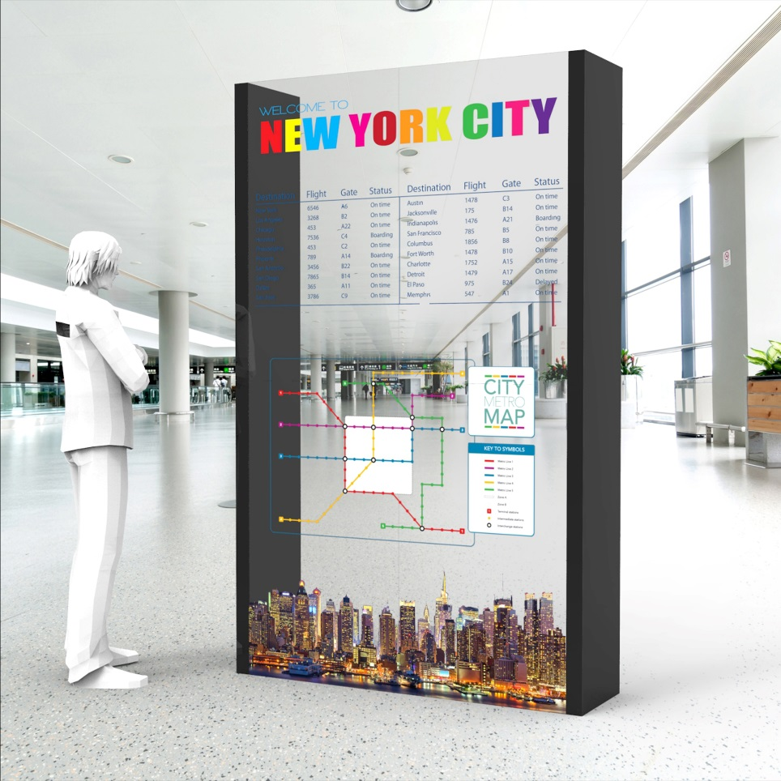
Figure 10 - Four displays tiled together in portrait orientation to create a video wall.
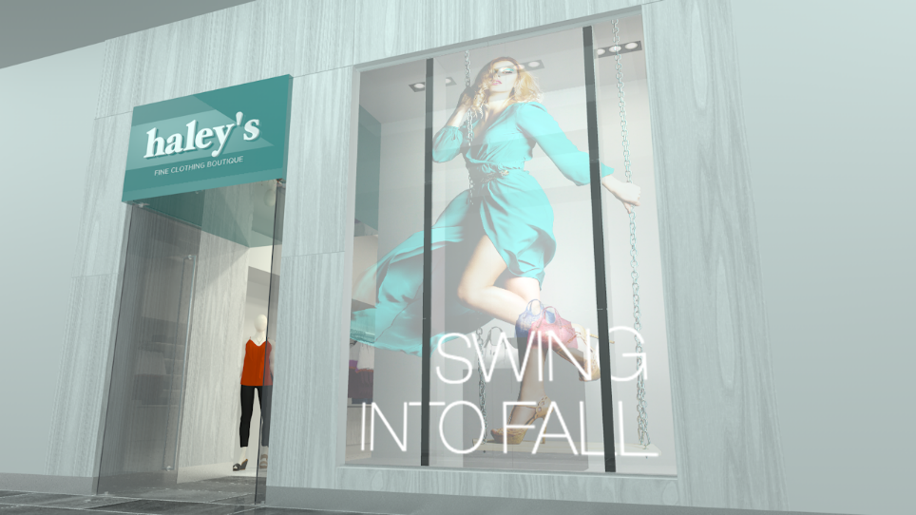
Figure 11 - Twelve displays tiled together in portrait to create a larger video wall.
For integrators to achieve these installations, they will want to work with a credible fabricator (in the form of an exhibit design or fixture maker, most commonly) to create the structure unique to their needs. Planar does not warrant the work of third-party fabricators or fixture makers.

Lifetime Considerations

Static and Moving Video Images
Customers can directly affect the lifetime and image performance of their displays by their content selections. Content drives both power usage and life-time. The more pixels are at rest (read: black content) the less power is consumed, the longer those pixels will last and the more transparent the display.
Lifetime is related to ours of life for each pixel, so we encourage customers and their agencies and content developers to keep the content mostly black and keep it active.
We HIGHLY advise against static content (ie, text, maps, static logos, station identification, score boards, desktop menus, etc). Even error messages, operating system update alerts should be disabled to avoid inadvertent burn-in.
The time to burn-in depends on the brightness of the static image or repeated video pattern. The worst or fastest burn-in will be with white or blue against a black background. The appearance of burn-in is most pronounced in those high-contrast environments where high energy colors are put in a low energy field of black. In this worst case scenario, you might expect the image to burn-in in approximately 300 hours.
For instance, a video clip with an average luminance of 150 nits might burn-in after 1,000 hours. In a clip with an average luminance of 70 nits (where most of the screen is black, most of the time), you might see burn-in after 2,200 hours.
The product is not warranted against user-caused damage of this type.

Accumulated Stress
The lifetime of the display is the accumulation of the lifetime of each pixel. This means that even if the bright or light areas of the content are moving around, if they always are in one corner of the screen, this can clock up hours on those pixels and contribute over time to permanent image retention or burn-in.

Other Lifetime Considerations
If the display is operated at elevated temperatures, that will affect lifetime. Furthermore, the panel is more subject to burn-in over time, due to the aging of the materials.

